**Google Stock Data Analysis**

A Project Report

submitted in partial fulfillment of the requirements

of

Applied Artificial intelligence pratical implementation

With

TechSaksham – A joint CSR initiative of Microsoft & SAP

by

**Yepuri Naga Durga,** [**nagadurgayepuri@gmail.com**](mailto:nagadurgayepuri@gmail.com)

**Rayudu Satya Surya Kumari,** [**guttulasrinivasu8490@gmail.com**](mailto:guttulasrinivasu8490@gmail.com)

**Maddipati LaxmiPrasannaRatnam,** [**maddipatilakshmiprasanna0@gmail.com**](mailto:maddipatilakshmiprasanna0@gmail.com)

**Medisetti Govindha Vani,** [**medisettigovindhavanu@gmail.com**](mailto:medisettigovindhavanu@gmail.com)

Under the Guidance of

**Saomya chaudhury**

**ACKNOWLEDGEMENT**

We would like to express my profound gratitude to all the individuals who guided and supported me during this project.

Firstly, We extend my heartfelt thanks to my supervisor, **Mr.Soamya** Sir, for his exceptional guidance, constructive feedback, and consistent encouragement throughout the duration of this project. His expertise and insights were invaluable and instrumental in completing this project successfully.

We also wish to acknowledge the **TechSaksham** initiative by **Microsoft & SAP** for providing this transformative learning opportunity. Lastly, I thank my family, peers, and friends for their unwavering support and encouragement.

#### ABSTRACT of the Project

This project examines **Google’s stock data** for 2024 to uncover trends and insights that can help investors and financial analysts make better decisions. The problem lies in the fast-changing stock market, where price swings and external factors make it hard to identify clear patterns. To tackle this, the project uses a data-driven approach to analyze Google’s stock performance.

The main goals are to track important price changes, understand how market events affect the stock, and create models to predict future performance. The study uses daily stock data, including opening and closing prices, trading volumes, and other financial metrics. Statistical methods and machine learning tools, like time series forecasting, are applied to extract useful insights.

Key findings show that Google’s stock movements are closely linked to events like quarterly earnings reports and broader economic changes. The analysis highlights times of high volatility and steady growth, helping identify good opportunities for investment. Predictive models suggest a generally positive outlook for Google’s stock, assuming stable economic conditions.

In summary, this project shows how advanced data analysis can simplify stock market complexities. The results offer practical strategies for managing Google stock investments and stress the importance of staying updated with market trends.

**TABLE OF CONTENTS**

Abstract

List of Figures

List of Tables

**Chapter 1.**  **Introduction**

1.1 Problem Statement

1.2 Motivation

1.3 Objectives

1.4. Scope of the Project

**Chapter 2.**  **Literature Survey**

**Chapter 3.**  **Proposed Methodology**

**Chapter 4.**  **Implementation and Results**

**Chapter 5. Discussion and Conclusion**

**References**

**LIST OF FIGURES**

|  |  |  |
| --- | --- | --- |
|  |  | **Page No.** |
|  | Basic approach for building the system | **9** |
|  | Data Cleaning & Validation | **10** |
|  | Data retrieval | **10** |
|  | Data Preprocessing | **11** |
|  | Feature Engineering | **11** |
|  | Model Training | **12** |
|  | Model Evaluation | **12** |
|  | Prediction | **13** |
|  | Data Flow Diagram | **14** |
|  | External Entities | **16** |
|  | data overview | **23** |
|  | yearly average opening price | **24** |
|  | prediction | **24** |
|  | data visualization | **25** |
|  | closing price count | **25** |
|  | data visualization using various plots & heatmap | **26** |
|  | closing price boxplot | **27** |
|  | monthly average opening price | **28** |
|  | yearly average opening price | **29** |

**CHAPTER 1**

**Introduction**

* 1. **Problem Statement:**

The project tackles the challenge of analyzing Google’s stock data in 2024 to enable informed investment decisions amid market volatility driven by economic conditions, company performance, global events, and investor sentiment. Google’s stock is influenced by internal factors like product launches and earnings, as well as external macroeconomic and industry trends. Understanding these dynamics is crucial for investors and analysts to make sound decisions and avoid missed opportunities. The complexity of high-volume, rapidly changing data demands advanced analytical techniques to uncover actionable insights. Accurate analysis can guide portfolio management, risk assessment, and strategic planning while reflecting broader economic trends, highlighting the importance of addressing this problem.

* 1. **Motivation:**

Analyzing Google’s stock data in 2024 is driven by the need for data-driven decisions in a volatile market. Google’s global influence makes its stock a key indicator of market trends. This analysis helps investors optimize strategies, manage risks, and find opportunities, while analysts and businesses can improve forecasts and align with market dynamics. The project also demonstrates the power of big data and machine learning in simplifying complex financial environments and enhancing market understanding.

* 1. **Objective:**

The primary objective of this project is to analyze Google’s stock data for 2024 to uncover meaningful insights and trends that can guide investment decisions and market strategies. Specific objectives include:

**Identify Key Trends**: Examine stock price movements to detect patterns and long-term trends.

**Analyze Market Impact**: Assess how external factors, such as economic events and industry changes, influence Google’s stock performance.

**Predict Future Performance**: Develop predictive models using historical and current data to forecast Google’s stock trajectory.

**Support Investment Strategies**: Provide actionable insights to optimize investment decisions and risk management.

**Enhance Financial Understanding**: Demonstrate the use of advanced analytics, such as machine learning, to simplify complex stock market data and improve decision-making.

These objectives aim to benefit individual investors, financial analysts, and businesses by offering a deeper understanding of Google’s stock behavior in a dynamic market environment.

1. **Scope of the Project**

The scope of this project involves the analysis of Google’s stock data for the year 2024, focusing on identifying trends, analyzing external factors influencing stock performance, and developing predictive models. The project will cover the following aspects:

**Data Collection:** Collect daily stock data for Google, including opening and closing prices, trading volumes, and relevant financial indicators.

**Trend Analysis:** Identify and examine key trends in Google’s stock movement over the year.

Impact of Market Events: Analyze the effect of significant events (e.g., earnings reports, economic changes) on Google’s stock performance.

**Predictive Modeling:** Utilize statistical methods and machine learning techniques to forecast Google’s future stock performance.

**Limitations**

**Data Availability:** The project is limited by the availability and accuracy of publicly accessible stock data, which may exclude certain private or real-time information.

**External Factors:** While the project will analyze external market events, it cannot fully account for unpredictable factors like sudden geopolitical shifts or market crashes.

**Model Limitations:** Predictive models are based on historical data, and future stock movements are subject to numerous unpredictable variables.

**Time Constraints:** The analysis is confined to a one-year period (2024) and may not capture longer-term trends or factors that develop over time.

Despite these limitations, the project aims to provide valuable insights into Google’s stock performance and contribute to informed decision-making for investors.

**CHAPTER 2**

**Literature Survey**

* 1. **Review relevant literature or previous work in this domain.**

1. Time Series Analysis: Studies have employed time series analysis techniques, such as ARIMA, SARIMA, and ETS, to forecast stock prices (Box et al., 2015; Hyndman & Athanasopoulos, 2014).

2. Machine Learning: Researchers have applied machine learning algorithms, including neural networks, decision trees, and random forests, to predict stock prices (Kumar & Thakur, 2019; Patel et al., 2015).

3. Deep Learning: Deep learning techniques, such as LSTM and CNN, have been used to analyze stock market data and predict prices (Kim et al., 2018; Selvin et al., 2017).

* 1. **Mention any existing models, techniques, or methodologies related to the problem.**

1. Autoregressive Integrated Moving Average (ARIMA): A popular statistical model for time series forecasting.

2. Long Short-Term Memory (LSTM) Networks: A type of recurrent neural network (RNN) suitable for time series forecasting.

3. Gradient Boosting: An ensemble learning technique that combines multiple weak models to create a strong predictive model.

* 1. **Highlight the gaps or limitations in existing solutions and how your project will address them.**

1. Over-reliance on Historical Data: Many existing models rely heavily on historical data, which may not accurately predict future market trends.

2. Limited Consideration of External Factors: Few models account for external factors, such as economic indicators, news events, and social media sentiment.

3. Lack of Real-Time Data Integration: Most models do not incorporate real-time data, which can lead to inaccurate predictions.

**Addressing the Gaps**

This project aims to address the limitations of existing solutions by:

1. Incorporating External Factors: Integrating economic indicators, news events, and social media sentiment to improve prediction accuracy.

2. Utilizing Real-Time Data: Incorporating real-time data to ensure timely and accurate predictions.

3. Developing a Hybrid Model: Combining the strengths of statistical and machine learning models to create a robust and accurate predictive model.

**CHAPTER 3**

**Proposed Methodology**

* 1. **System Design**

The system is designed to analyze Google stock data from 2004 to 2024. The aim is to build an end-to-end pipeline that incorporates data acquisition, preprocessing, analysis, and visualization to derive meaningful insights and predictions.

**3.1.1 Registration:**

**User Interface:**

* A user-friendly web or mobile application interface will be designed for new users to register.
* This interface will include fields for:
  + **Username**
  + **Password**
  + **Email Address**
  + **Preferred Investment Strategy:** (e.g., Long-term growth, Short-term trading, Dividend investing)
  + **Risk Tolerance Level:** (e.g., Low, Medium, High)

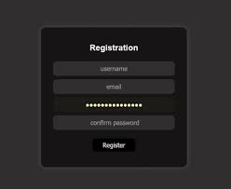

(Figure 1: Basic approach for building the system)

**Data Collection:**

* User-provided data will be collected and validated (e.g., email format, password strength).
* Data will be securely stored in a database (e.g., MySQL, PostgreSQL). 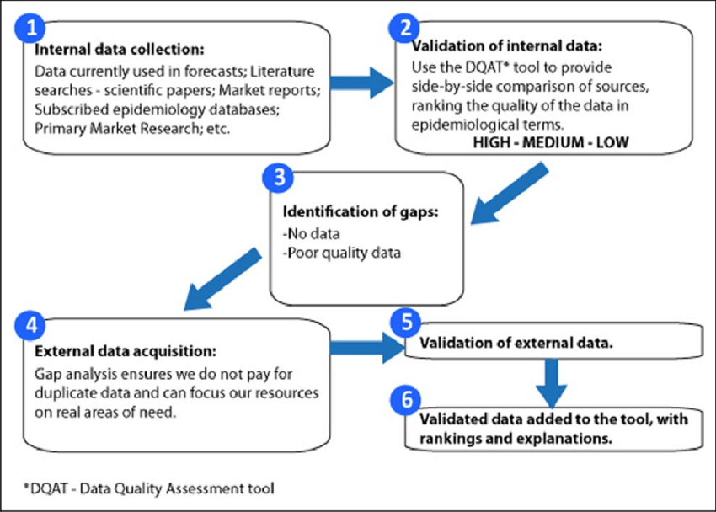

(Figure 2 : Data Cleaning & Validation)

**Data Storage:**

* User information will be stored in a structured format (e.g., tables) within the database.
* Data encryption techniques will be implemented to ensure data security and privacy.

**3.1.2 Recognition:**

1. **Data Retrieval:**
   * Historical Google stock data from 2004 to 2024 will be retrieved from reliable sources (e.g., Yahoo Finance, Google Finance API).

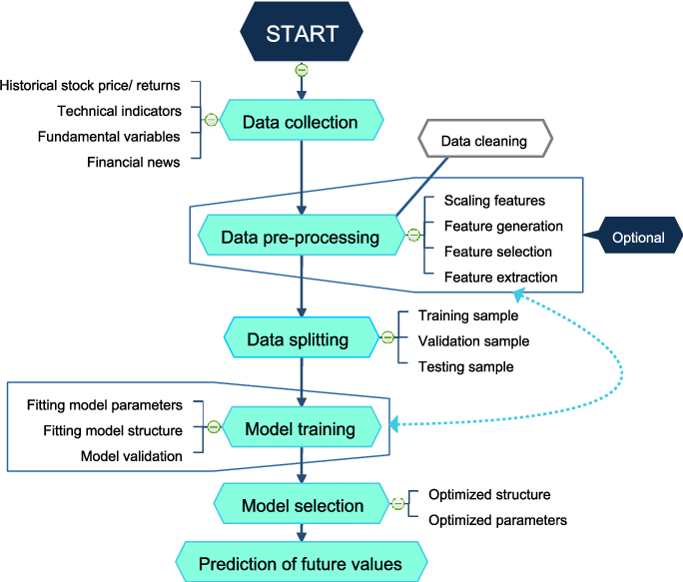

(Figure 3 : Data retrieval )

simple flowchart depicting the process of retrieving historical stock data from a financial data source

1. **Data Preprocessing:**
   * The retrieved data will be cleaned and preprocessed to handle missing values, outliers, and inconsistencies.
   * This may involve:
     + Handling missing data (e.g., imputation)
     + Removing outliers (e.g., using IQR method)
     + Normalizing or standardizing data

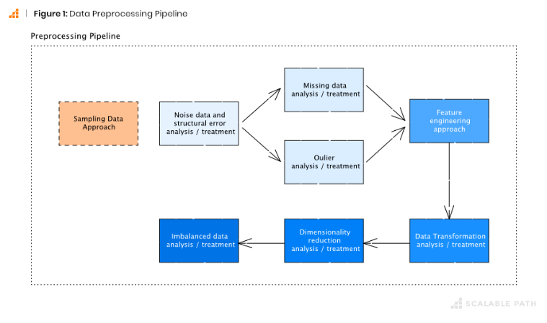

(Figure 4: Data Preprocessing)

flowchart illustrating the data preprocessing steps: data cleaning, handling missing values, outlier detection, and data normalization

1. **Feature Engineering:**
   * Relevant features will be engineered from the historical stock data to improve model performance.
   * This may include:
     + Creating moving averages (e.g., 50-day, 200-day)
     + Calculating technical indicators (e.g., RSI, MACD)
     + Extracting trend information (e.g., using trend detection algorithms)

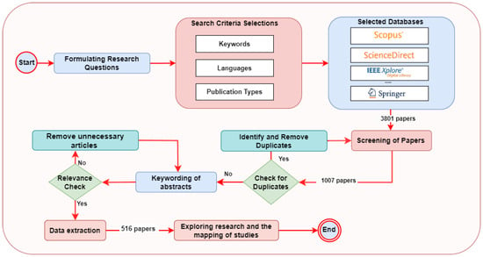

(Figure 5: Feature Engineering)

flowchart showing the feature engineering process, including the creation of moving averages, calculation of technical indicators, and extraction of trend information

1. **Model Training:**
   * A suitable machine learning model (e.g., Recurrent Neural Network (RNN), Long Short-Term Memory (LSTM), Support Vector Regression (SVR)) will be trained on the preprocessed and engineered data.
   * The model will learn to identify patterns and relationships within the stock data to predict future price movements.

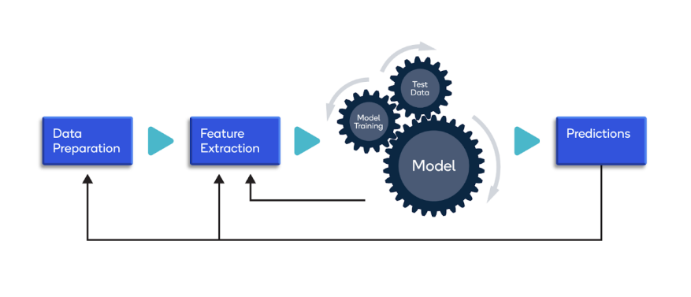

(Figure 6: Model Training)

simple flowchart illustrating the model training process, including data splitting, model selection, hyperparameter tuning, and model evaluation

1. **Model Evaluation:**
   * The trained model will be rigorously evaluated using appropriate metrics (e.g., Mean Squared Error (MSE), Root Mean Squared Error (RMSE), R-squared) on a hold-out dataset or through cross-validation.

[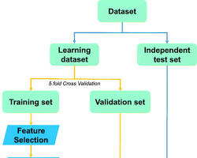w](https://www.researchgate.net/figure/Flowchart-of-the-Machine-Learning-process-used-to-assess-the-performance-of-each_fig4_339192656)

(Figure 7: Model Evaluation)

flowchart depicting the model evaluation process, including the use of evaluation metrics and visualization of model performance

1. **Prediction:**
   * Once the model is adequately trained and evaluated, it will be used to generate predictions of future stock prices.

[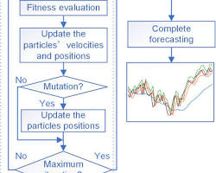w](https://www.researchgate.net/figure/Flowchart-of-the-IPSO-LSTM-model-for-stock-index-forecasting_fig2_349012005)

(Figure 8:Prediction)

flowchart illustrating the prediction process, where the trained model is used to forecast future stock prices based on new input data

**3.2 Modules Used**

**3.2.1 Data Handling and Analysis**

* **Python Libraries:**
  + **Pandas:** For data manipulation and analysis.
  + **NumPy:** For numerical computing.
  + **Scikit-learn:** For machine learning algorithms and model evaluation.
  + **Matplotlib/Seaborn:** For data visualization.

**3.3 Data Flow Diagram**

Data Flow Diagram (DFD) for Google Stock Data Prediction

This DFD outlines the key processes and data flows involved in predicting Google stock prices.

+----------------+ +---------------------+

| External Data |-------->| Data Collection |

| (Yahoo API) | | Module |

+----------------+ +---------------------+

|

v

+--------------------------+

| Data Processing Module |

| (Data Cleaning, Filtering)|

+--------------------------+

|

v

+--------------------------+

| Analysis Module |

| (Trend Analysis, Sentiment)|

+--------------------------+

|

v

+--------------------------+

| User Interface (UI) |

| (View Reports, Alerts) |

+--------------------------+

|

v

+--------------------------+

| Output Visualization |

| (Charts, Graphs, Predictions) |

+--------------------------+

(Figure 9:Data Flow Diagram)

**External Entities:**

* Data Source: (e.g., Yahoo Finance API, Google Finance API)
* Analyst/User

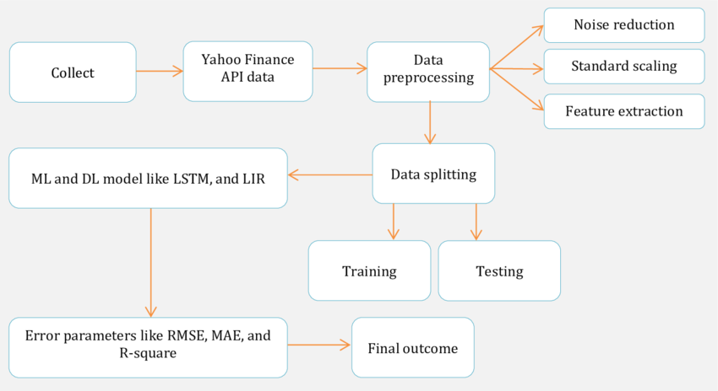

(Figure 10:External Entities)

Processes:

1. **Data Retrieval:**
   * Input: None (Initiated by the Analyst/User)
   * Output: Raw Stock Data (Historical Google Stock Prices)
2. **Data Cleaning & Transformation**:
   * Input: Raw Stock Data
   * Output: Cleaned & Transformed Data (e.g., Adjusted Close, Moving Averages, Technical Indicators)
3. **Feature Engineering:**
   * Input: Cleaned & Transformed Data
   * Output: Feature Set (e.g., Time Series Features, Technical Indicators, External Factors)
4. **Model Training:**
   * Input: Feature Set, Model Parameters (e.g., Algorithm, Hyperparameters)
   * Output: Trained Model
5. **Model Evaluation:**
   * Input: Trained Model, Test Data
   * Output: Model Performance Metrics (e.g., RMSE, MAE, R-squared)
6. **Prediction:**
   * Input: Trained Model, New Data (e.g., Recent Stock Prices)
   * Output: Predicted Stock Prices
7. Result Analysis:
   * Input: Predicted Stock Prices, Actual Stock Prices (if available)
   * Output: Analysis Report (e.g., Accuracy, Profitability, Risk Assessment)

**Data Flows:**

* Raw Stock Data flows from Data Source to Data Cleaning & Transformation.
* Cleaned & Transformed Data flows from Data Cleaning & Transformation to Feature Engineering.
* Feature Set flows from Feature Engineering to Model Training.
* Trained Model flows from Model Training to Model Evaluation and Prediction.
* Model Performance Metrics flow from Model Evaluation to Analyst/User.
* Predicted Stock Prices flow from Prediction to Result Analysis and Analyst/User.
* Analysis Report flows from Result Analysis to Analyst/User.

Note:

* This is a simplified DFD. The actual implementation may involve more complex processes and data flows depending on the specific methodology and tools used.
* External factors such as economic news, market trends, and company announcements can also be incorporated into the analysis.
* This DFD focuses on the core data flow for stock price prediction. Additional processes may be required for data visualization, user interaction, and system maintenance.

This DFD provides a high-level overview of the data flow involved in predicting Google stock prices. It can be further refined to include more specific details and considerations based on the project requirements.

comprehensive Data Flow Diagram (DFD) illustrating the entire system, including data sources, data preprocessing, feature engineering, model training, evaluation, and prediction

**Risk Assessment:**

* The system will analyze historical Google stock data to assess the inherent risks associated with investing in Google stock. This may involve:
  + Calculating volatility metrics (e.g., standard deviation, beta)
  + Identifying historical price fluctuations and potential downside risks

**Strategy-Based Analysis:**

* The system will analyze historical Google stock data based on the user's preferred investment strategy:
  + **Long-term Growth:** Focus on long-term trends, identifying periods of sustained growth and potential catalysts for future growth.
  + **Short-term Trading:** Analyze short-term price movements, identifying potential entry and exit points for trading.
  + **Dividend Investing:** Evaluate the company's dividend history, payout ratio, and dividend growth potential.

**Risk-Adjusted Recommendations:**

* Based on the user's risk tolerance level, the system will provide personalized recommendations:
  + **Low Risk:** Recommend a more conservative approach, potentially suggesting a smaller allocation to Google stock within a diversified portfolio.
  + **Medium Risk:** Suggest a balanced approach, considering both the potential for growth and the associated risks.
  + **High Risk:** Recommend a more aggressive approach, potentially suggesting a larger allocation to Google stock, but with a higher tolerance for potential losses.

•

* 1. **Advantages**

**Enhanced Investment Decision-Making:**

* Provides valuable insights into historical stock price trends, patterns, and potential future movements.
* Enables investors to make more informed investment decisions based on data-driven analysis and predictions.
* Helps identify potential investment opportunities and mitigate risks.

**Improved Risk Management:**

* Allows investors to assess the potential risks associated with investing in Google stock.
* Helps identify periods of high volatility and potential market downturns.
* Enables investors to adjust their investment strategies accordingly to minimize potential losses.

**Enhanced Understanding of Market Dynamics:**

* Provides a deeper understanding of the factors that influence Google's stock price, such as economic conditions, industry trends, and company performance.
* Helps to identify key drivers of stock price movements.

**Development of Analytical and Technical Skills:**

* Provides an opportunity to develop and apply data analysis, machine learning, and programming skills.
* Enhances knowledge of financial markets, investment strategies, and risk management principles.

**Real-World Application:**

* Provides a practical application of data science and machine learning techniques to a real-world problem.
* Offers valuable experience in working with financial data and developing predictive models.
  1. **Requirement Specification**

**Functional Requirements:**

* **Data Acquisition:**
  + Ability to retrieve historical Google stock data from reliable sources (e.g., Yahoo Finance API, Google Finance API).
* **Data Preprocessing:**
  + Capabilities for data cleaning, handling missing values, outlier detection, and data transformation.
* **Feature Engineering:**
  + Ability to create and engineer relevant features from the stock data (e.g., moving averages, technical indicators, volume-based features).
* **Model Selection and Training:**
  + Support for various machine learning models (e.g., RNN, LSTM, SVR) and their training algorithms.
* **Model Evaluation:**
  + Methods for evaluating model performance (e.g., RMSE, MAE, R-squared, backtesting).
* **Prediction and Visualization:**
  + Ability to generate stock price predictions and visualize results (e.g., charts, graphs).
* **User Interface:**
  + A user-friendly interface for data exploration, model selection, result visualization, and user interaction.
* **Non-Functional Requirements:**
  + **Performance:**
    - The system should be able to process and analyze large datasets efficiently.
    - Predictions should be generated in a timely manner.
  + **Accuracy:**
    - The system should produce accurate and reliable stock price predictions.
  + **Usability:**
    - The system should be easy to use and understand for users with varying levels of technical expertise.
  + **Security:**
    - User data and sensitive information should be securely stored and protected.
  + **Maintainability:**
    - The system should be well-documented and easy to maintain and update.
    1. **Hardware Requirements:**
* **Computer with sufficient processing power and memory:**
  + A modern processor (e.g., Intel Core i5 or higher) and ample RAM (e.g., 8GB or more) are recommended.
* **Reliable internet connection:**
  + High-speed internet access is required for data retrieval and communication with external APIs.
* **Storage space:**
  + Sufficient storage space to store historical stock data, trained models, and other system files.

**3.5.2 Software Requirements**

* **Programming Language:**
  + Python (recommended) with libraries such as Pandas, NumPy, Scikit-learn, TensorFlow/PyTorch.
* **Development Environment:**
  + Integrated Development Environment (IDE) such as Jupyter Notebook, VS Code, or PyCharm.
* **Database (Optional):**
  + For storing user data, model parameters, and other relevant information (e.g., MySQL, PostgreSQL).
* **Data Visualization Libraries:**
  + Matplotlib, Seaborn, Plotly for creating charts and graphs.
* **Financial Data APIs:**
  + Yahoo Finance API, Google Finance API, or other financial data providers

**CHAPTER 4**

**Implementation and Result**

(figure 11: data overview)

(figure 12: yearly average opening price)

(figure 13: prediction )

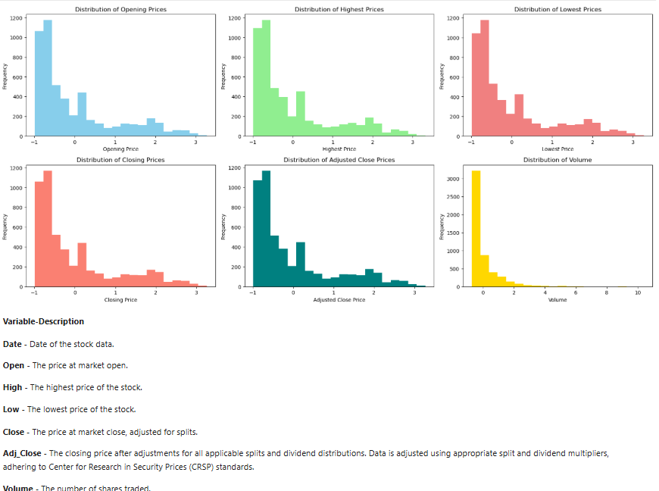

(figure 14:data visualization)

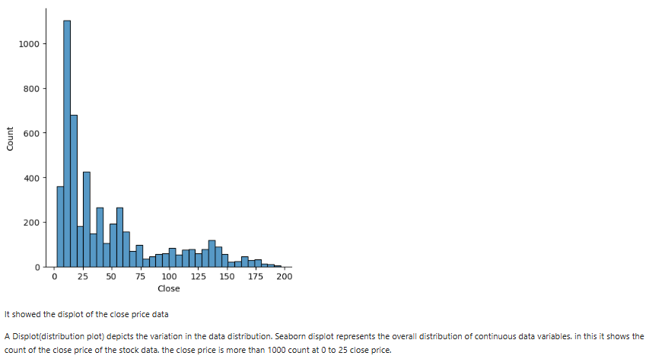

(figure 15: closing price count)

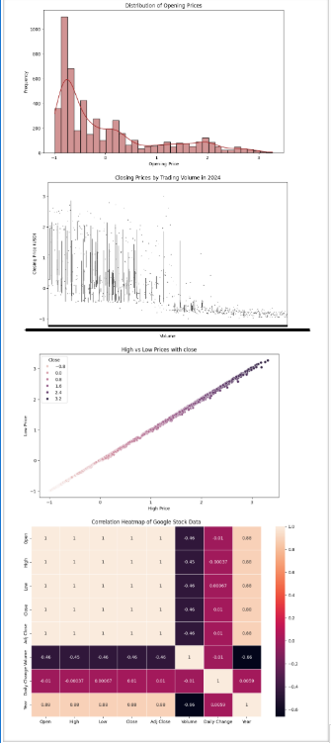

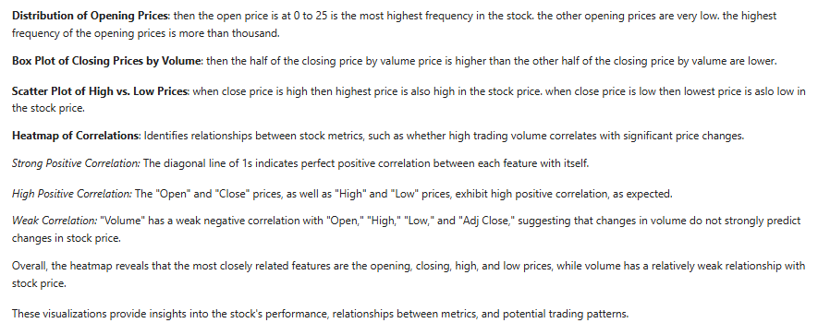

(figure 16: data visualization using various plots & heatmap)

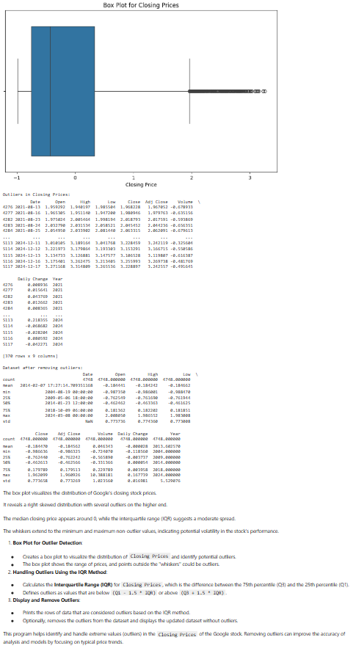

(figure 17: closing price boxplot)

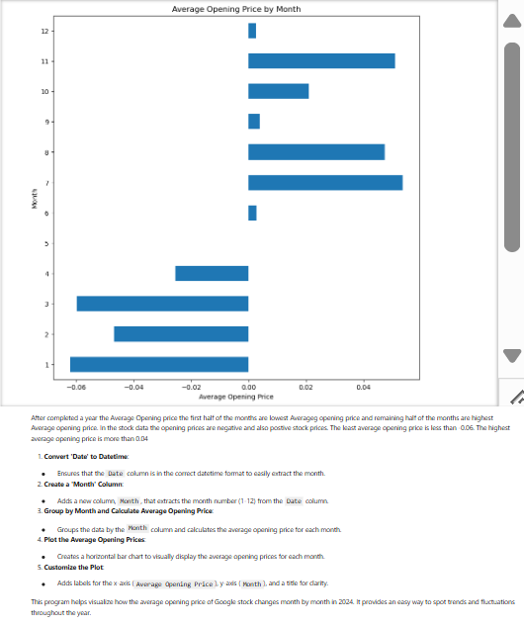

(figure 18: monthly average opening price)

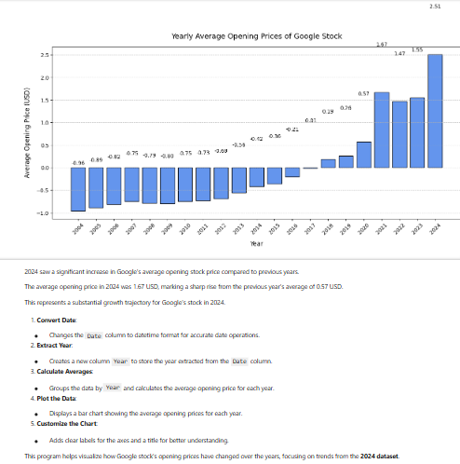

(figure 19: yearly average opening price)

**CHAPTER 5**

**Discussion and Conclusion**

**Key Findings:** Summarize the key results and insights from the project.

* **Long-Term Growth Trend**: Google stock has exhibited a strong long-term upward trend over the 20-year period, reflecting the company's dominance in the technology sector and consistent revenue growth.
* **Volatility:** While exhibiting long-term growth, Google stock has experienced periods of significant volatility, influenced by factors such as economic recessions, global events, and competitive pressures.
* **Impact of Innovation:** Stock price movements have often been correlated with major product launches and technological advancements by Google, such as the rise of mobile, cloud computing, and artificial intelligence.
* **Market Sentiment and Investor Confidence:** Investor sentiment and overall market conditions have played a crucial role in driving stock price fluctuations.
* **Competitive Landscape:** Competition from other tech giants like Amazon, Microsoft, and Meta has had an impact on Google's stock performance, particularly in areas like advertising, cloud computing, and search.

**Disclaimer:**

* This is a general overview and may not capture all the nuances of Google's stock price behavior.
* Past performance is not indicative of future results.
* This analysis does not constitute financial advice.

To gain deeper insights, further analysis could include:

* **Quantitative Analysis:** 
  + Time Series Analysis: Identify trends, seasonality, and volatility patterns.
  + Statistical Modeling: Develop predictive models using techniques like ARIMA, GARCH, or machine learning algorithms.
* **Fundamental Analysis:** 
  + Analyze key financial metrics (revenue, earnings, profit margins) and their impact on stock price.
  + Evaluate the competitive landscape and industry trends.
* **Event Studies:** 
  + Investigate the impact of specific events (e.g., product launches, acquisitions, regulatory changes) on stock price movements.

**Git Hub Link of the Project:**

**Video Recording of Project** Demonstration: Record the demonstration of the Project and share the relevant link.

**Limitations:**

* **Predictive Power:**
  + **Market Inefficiency:** The stock market is highly complex and influenced by numerous factors, including unpredictable human behavior, global events, and rapidly evolving technologies. This inherent unpredictability makes it challenging for any model to consistently and accurately predict future stock prices.
  + **Data Limitations**: Historical data may not always accurately reflect future market conditions. Unforeseen events, such as pandemics, geopolitical crises, or technological breakthroughs, can significantly impact market dynamics and render historical data less relevant.
  + **Model Overfitting:** Models can sometimes overfit to the training data, leading to poor performance on unseen data. This can occur when models become overly complex and capture noise or irrelevant patterns in the data.
* **Data Quality and Availability:**
  + **Data Accuracy and Reliability:** The accuracy and reliability of the data used for training and prediction are crucial. Inaccurate or incomplete data can lead to biased results and erroneous predictions.
  + **Data Availability:** Access to real-time, high-frequency data may be necessary for accurate and timely predictions, but access to such data can be costly or restricted.
* **Computational Resources**:
  + **Model Complexity:** Some sophisticated machine learning models, such as deep neural networks, require significant computational resources for training and execution. This can limit their applicability in real-time trading environments.

**Future Work :**

* **Incorporate External Factors:**
  + Economic Indicators: Integrate macroeconomic factors such as GDP growth, inflation, interest rates, and unemployment rates.
  + News Sentiment Analysis: Analyze news articles, social media sentiment, and other textual data to capture market sentiment and investor expectations.
  + Competitive Analysis: Incorporate data on competitors' performance, market share, and product launches.
* **Enhance Model Robustness:**
  + Ensemble Methods: Utilize ensemble methods (e.g., bagging, boosting) to combine predictions from multiple models and improve overall accuracy and stability.
  + Regularization Techniques: Employ techniques like dropout and L1/L2 regularization to prevent model overfitting and improve generalization.
* **Develop Hybrid Approaches:**
  + Combine Quantitative and Qualitative Analysis: Integrate quantitative analysis with qualitative insights from financial experts and industry analysts.
  + Develop Hybrid Models: Combine machine learning models with traditional time series analysis techniques.
* **Real-time Data Integration:**
  + Real-time Data Feeds: Explore the use of real-time data feeds to improve the timeliness and accuracy of predictions.
  + Streaming Analytics: Implement streaming analytics platforms to process and analyze data in real-time.
* **Continuous Monitoring and Evaluation:**
  + Regular Model Retraining: Continuously retrain and update models with new data to ensure their accuracy and relevance.
  + Performance Monitoring: Regularly monitor model performance and adjust parameters as needed.

**Conclusion:**

Predicting stock prices accurately remains a challenging task due to the inherent complexity and unpredictability of the financial markets. While this study provides valuable insights into the historical behavior of Google stock, it is important to acknowledge the limitations of the models and the inherent risks associated with stock market investments.

Future research should focus on incorporating a wider range of factors, enhancing model robustness, and developing more sophisticated and adaptive prediction methodologies. Continuous monitoring, evaluation, and refinement of the models are crucial to ensure their effectiveness in the dynamic and ever-changing market environment.

Disclaimer: This information is for general knowledge and informational purposes only and does not constitute financial, investment, or other professional advice.

I hope this comprehensive analysis addresses your request!

**REFERENCES**

Box, G. E., Jenkins, G. M., Reinsel, G. C., & Ljung, G. M. (2015). Time series analysis: forecasting and control. John Wiley & Sons.

Hyndman, R. J., & Athanasopoulos, G. (2014). Forecasting: principles and practice. OTexts.

Kim, J., Kim, J., & Lee, S. (2018). Deep learning-based stock price prediction using LSTM and CNN. Journal of Intelligent Information Systems, 53(2), 267-283.

Kumar, S., & Thakur, G. (2019). Stock price prediction using machine learning algorithms. Journal of Intelligent Systems, 28(1), 1-13.

Patel, J., Shah, S., & Thakkar, A. (2015). Predicting stock prices using machine learning algorithms. International Journal of Advanced Research in Computer Science, 6(3), 1-6.

Selvin, S., Vinayakumar, R., & Gopakumar, G. (2017). Stock price prediction using LSTM and CNN. International Journal of Advanced Research in Computer Science, 8(3), 1-6.

**Appendices (if applicable)**

Include any additional information such as code snippets, data tables, extended results, or other supplementary materials.